# Data Cleaning

1. Use info function to get the information about the data frame  
     
     
   Results: There are 4425 observations and 2 variables in the dataframe. The 2 variables are ‘date’ and ‘close’. It also shows the first few rows and last few rows of the dataframe  
   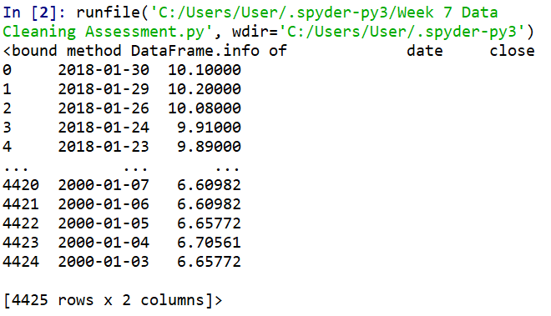
2. Use describe function to get statistics on ‘close’ variable  
     
     
   Results: The lowest close price is 3.574330 and the highest close price is 10.740000  
   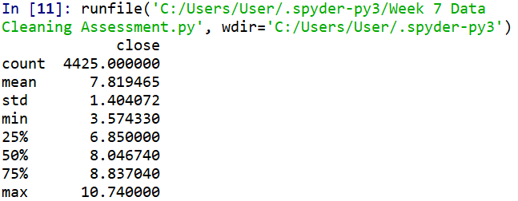
3. Check if dataframe contains null value  
     
     
   Results: There are no null value in both the variables  
   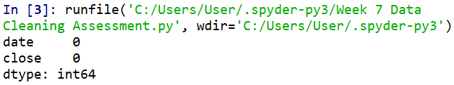
4. Check the data type of ‘date’ variable  
     
     
   Results: Content of ‘date’ variable is string  
   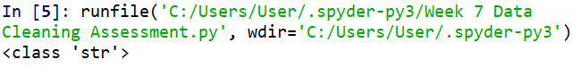
5. To check if content of ‘date’ conforms to the format of date data type, loop through every observation in ‘date’ variable while applying search function to count the number of observation when the content of ‘date’ is does not start with 4 numbers (year component), follows by ‘-‘, follows by 2 numbers (month component), follows by ‘-‘, follows by 2 numbers (day component)  
   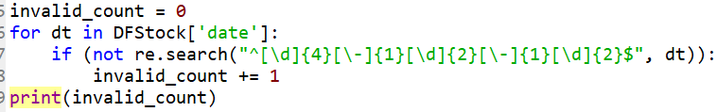  
     
   Results: All observations under ‘date’ is in correct format  
   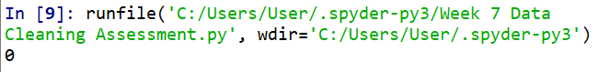
6. Check the data type of ‘close’ variable  
     
     
   Results: Content of ‘close’ variable is float that can be used directly to plot graph for trend analysis